

Centerprise Data Integrator
Speed ● Scalability ● Value

Installation Guide
Disclaimer
© Astera Software Corporation, 2010 - All Rights Reserved. This guide contains unpublished material containing trade secrets and is subject to a confidentiality agreement. Information in this document is subject to change without notice and does not represent a commitment on the part of Astera Software Corporation. The unauthorized possession, use, reproduction, display, or disclosure of this material or information contained herein is prohibited.
Microsoft® Windows, Visual Studio .NET, Systems Management Server and SQL Server are trademarks or registered trademarks of Microsoft Corporation. All other trademarks are the properties of their respective owners. Proprietary trademarks are distinguished from descriptive terms throughout this specification by following the capitalization style used by the manufacturer.
Astera Software Corporation
16530 Ventura Blvd. Suite 407
Encino, CA (USA) 91436
(818) 575-1201
www.astera.com
Contents
Installing Centerprise Data Integrator 4
Upgrading from an Earlier Version of Centerprise 7
Starting Centerprise 7
Licensing Centerprise Studio 8
Licensing Centerprise Server 9
Troubleshooting License Issues 10
Errors While Activating 10
Other Licensing Issues 11

Installing Centerprise Data Integrator

To start the installation of Centerprise 5, run setup.exe.
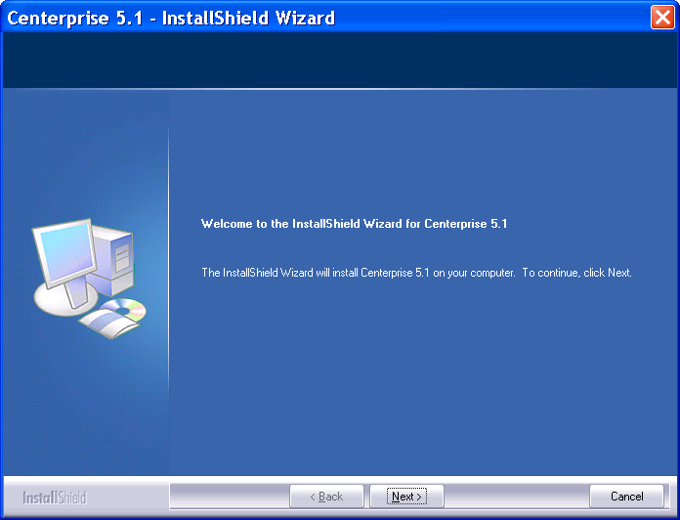

To continue with the installation, you must read and agree to the license terms.
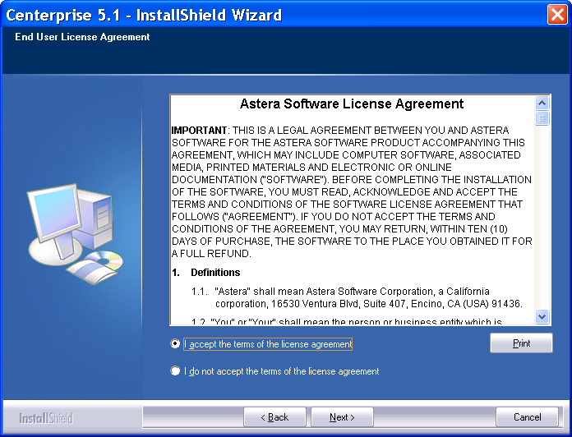
Enter the user name and company name, and specify who will use the application. Choosing the "Anyone who users this computer" option will install with shortcut available for any user that uses this machine.
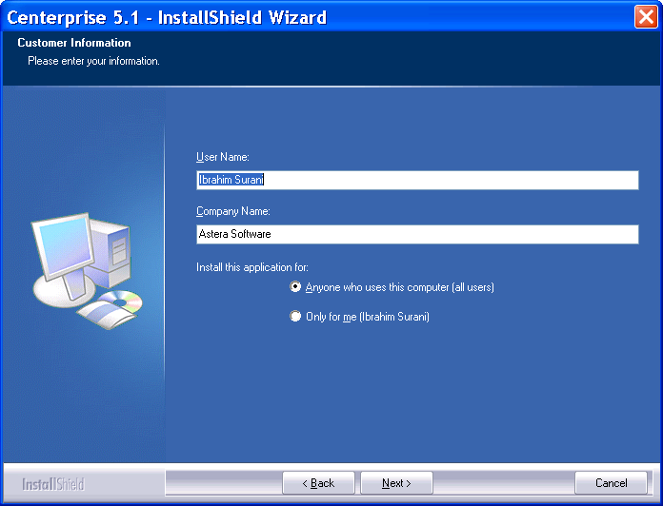

Choose between default or custom installation. To accept default installation options, select Studio and Server Default as shown below (applies to Enterprise or Premium Edition only).
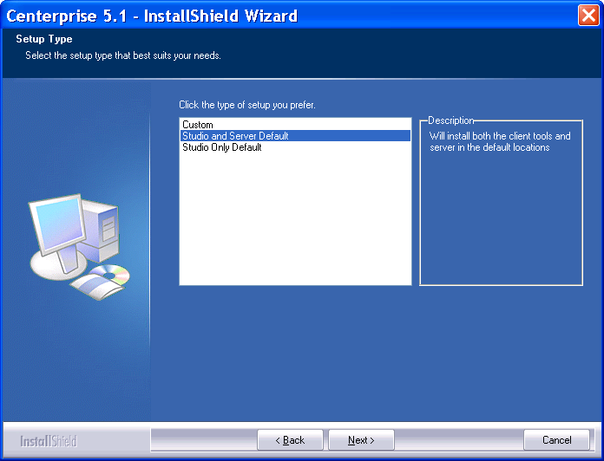
Optionally, you can install the Studio only, without installing the Server. This is achieved by selecting Studio Only Default. (This is the only option available for Standard and Professional Editions).
You can also customize your installation by selecting Custom. The following options are available for a custom installation:
Enter Destination Path. The default installation folder is C:\Program Files\Astera Software\Centerprise Data Integrator 5.
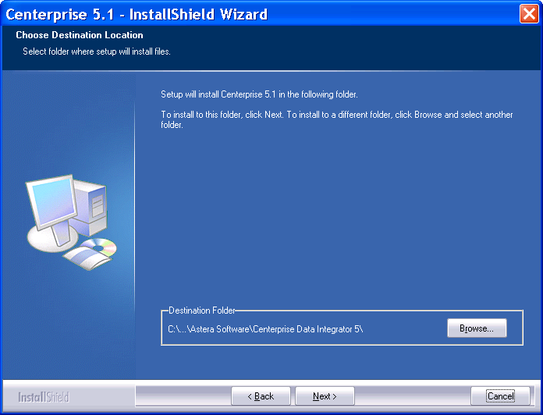

Select which components should be installed: Data Integrator Design Studio &/or Data Integrator Server.
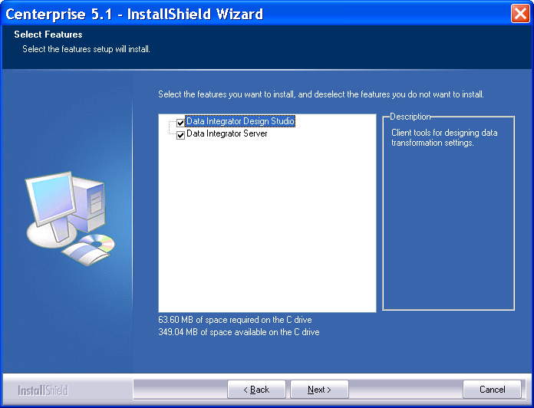
Enter the port number for the Data Integrator Server (Server). Connections to the server will be made using that port number. The default port number is 9257.
Finally, specify if Server should be started after the installation completes.
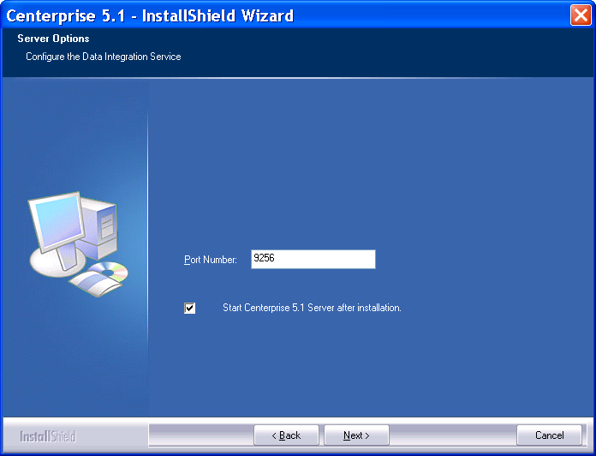
This completes the configuration steps, and you are now ready to complete the installation.

Upgrading from an Earlier Version of Centerprise
To upgrade from an earlier version of Centerprise (for example, to upgrade from 5.0 to 5.1), you need to uninstall the previous version first.
To upgrade to a new build within the same major version (for example, to upgrade from 5.1.32 to 5.1.46), you can run the Installer for the latest build. The installer will upgrade the Centerprise application for you keeping any previous configuration options unchanged.

Starting Centerprise
To start Centerprise Studio using a Windows shortcut, navigate to
All Programs -> Astera Software -> Centerprise Data Integrator 5 -> Centerprise Data Integrator 5.
The Centerprise Studio executable’s default location is
C:\Program Files\Astera Software\Centerprise Data Integrator 5\Client\Centerprise5.exe

Licensing Centerprise Studio
When you first start Centerprise Studio, you will see the Register Centerprise Data Integrator screen. To use Centerprise Studio, you must enter either a trial key or a license key in the Serial Number input.
To request a trial key, click the ‘Don’t have a serial number?’ link and follow the instructions on the web page.
You can also register directly at http://www.astera.com/centerprise/Request-Trial-Key.aspx
You must also enter your name, your company name, and the serial number provided to you.
Enter in the required information and click Unlock.

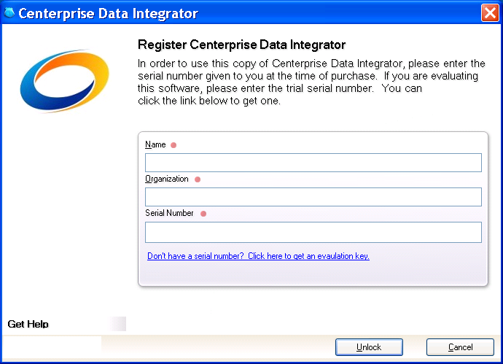

At this point, the software will contact Astera’s licensing server and register your copy. If this not a trial key, it will also lock this key to your machine so that the key cannot be used again on another machine unless the key is deactivated via the Deactivate License wizard from within the product.
If you enter a trial key, the registration screen will appear every time Centerprise is run, showing how many days of trial are left.
At the end of your trial period, you will be asked to register a non-trial license key..

Licensing the Server Component
Licensing the Data Integrator Server (Server) is separate from the licensing of Centerprise Studio.
Prior to running any jobs on the Server, you must install a license using Server License Manager.
To run Server License Manager, go to:
All Programs -> Astera Software -> Centerprise Data Integrator 5 -> Server License Manager.
The Server License Manager executable’s default location is
C:\Program Files\Astera Software\Centerprise Data Integrator 5\Server\ ServerLicenseUI.exe
The remaining steps of the server licensing process are similar to the client licensing described above.
Note: The Server must be restarted in order for the new license to take effect.
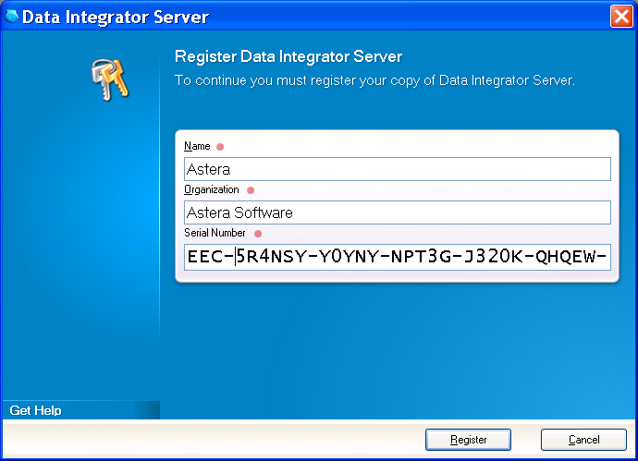

Troubleshooting License Issues

Errors While Activating
If you get an error while registering or activating, click the Details… button to display the details of the issue.
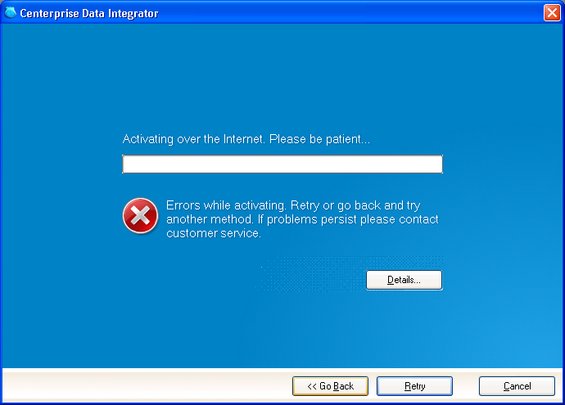
In the example shown below, activation is not allowed since the limit of activations has been reached for this license. You must deactivate the license from the original workstation and then try activating it again.
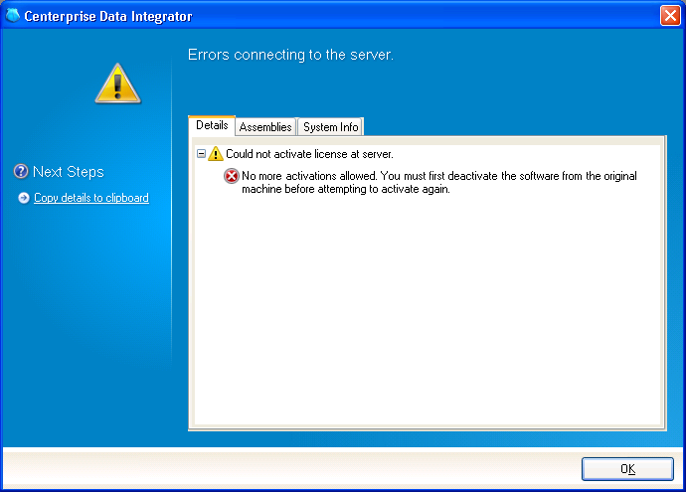

If your license has an expiration date, you may be prompted to extend it. Please contact support@astera.com to request an extension code.
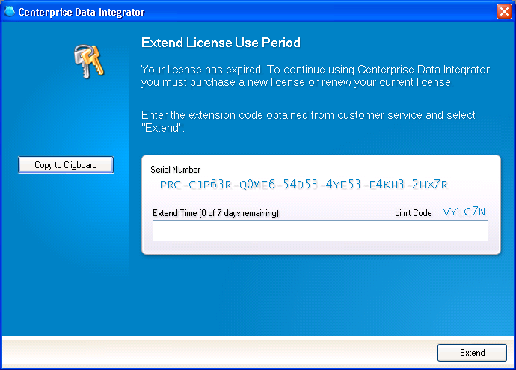

Other Licensing Issues
If you believe you have a valid license and are still having issues, try deleting the license file (.lic file) found in Centerprise's shared data folder. This can usually be found at
C:\Documents and Settings\All Users\Application Data\Astera Software\
in XP and
C:\Program Data\Astera Software\
in Vista / Windows 7.
In this folder, expand the respective sub folder for the client or the server depending on which edition was installed.
Note: You might have to change folder settings to show hidden files.

